Ezequiel Villanueva, Logan Doizaki

Dr. Elgzil

CPE 4700

22 November 2024

Digital Image Processing Device

**Overview:**

The purpose of this project is to develop a device which processes an image and applies RGB manipulation through user-based input.

**How the project works:**

1. The device is connected to a microcontroller (MCU) with the ability to take, store, and display images.
2. The MCU captures a picture (storing it on the MCU) using the camera attached and displays the unedited image on the display the MCU is attached to.
3. Using the MCU, the whole image file is sent to the Color Device filter where it will be stored temporarily.
4. On the device, when the image is received, the user can select between 3 buttons. The 3 buttons control the red, green, and blue filters. The buttons, when enabled, take out 100% of the selected color.
5. After the user selects their modifiers, the color filter works by utilizing multiplexers, multipliers, adders, and shifters to apply the change to the image stored locally.
6. After digitally altering the image, the processed image is stored on the device.
7. The image is then sent back to the MCU.
8. The MCU is used to display modified images on the display.

*Block Diagrams:*

Color Filter

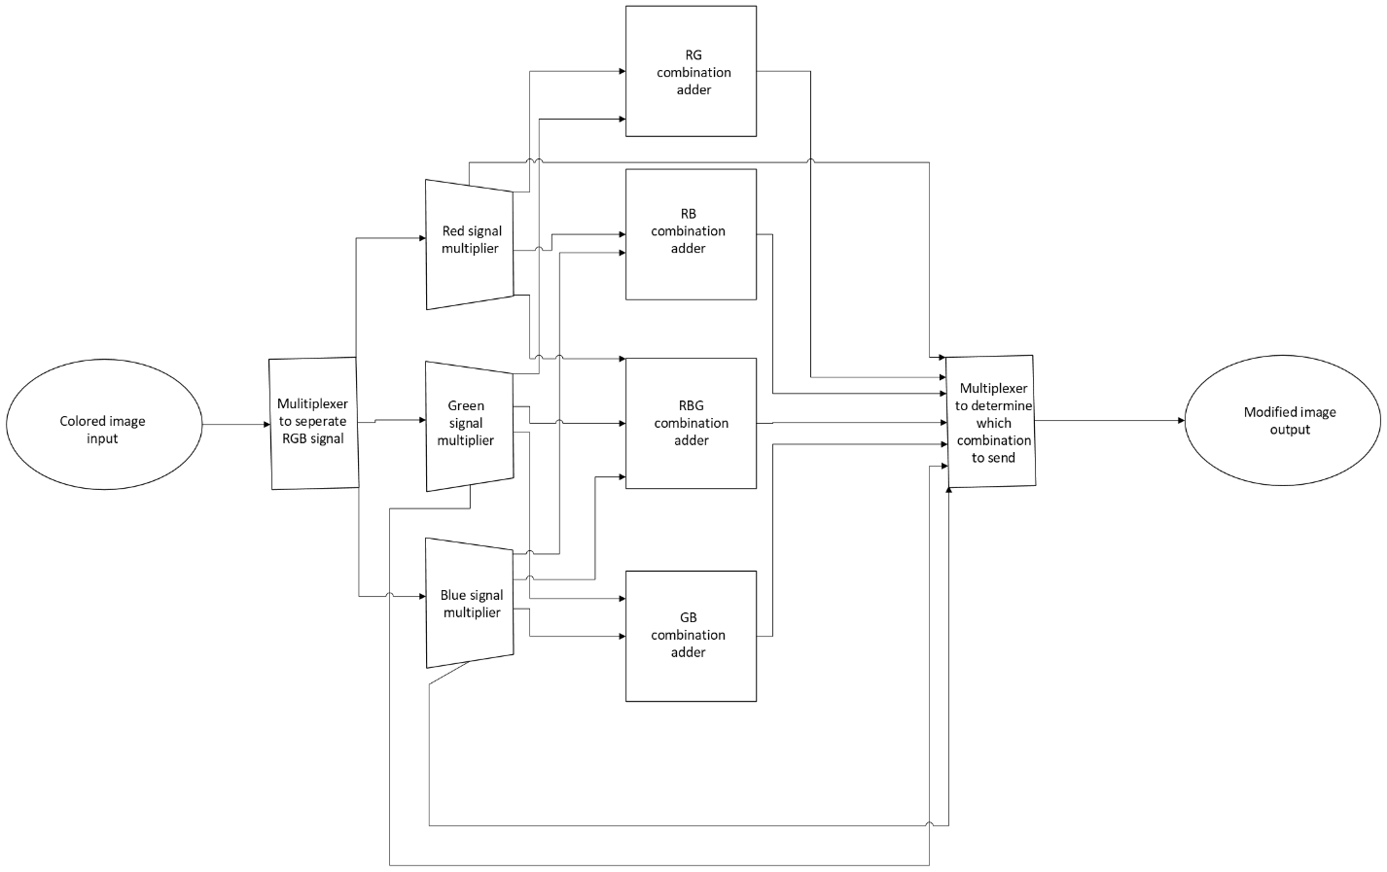

Basic Functionality

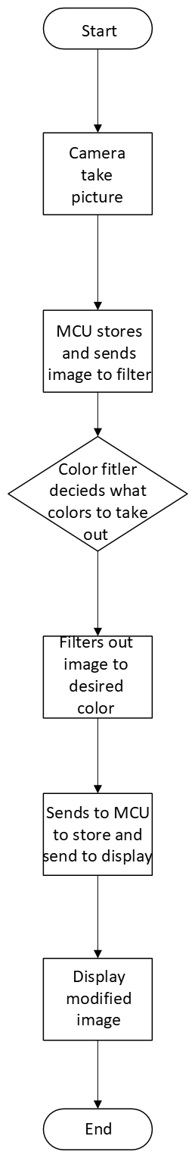

**Why this project?**

This project introduces students to digital image processing and file management. Since images are stored in bits, students would have to learn in detail how images are stored to be able to remove red, blue, or green colors. Furthermore, since the device performs the color processing on the device, students would have to understand how to store and modify the images on the device without losing information. To add, the project can be equivalently divided for each members strengths/weakness.

**Development Process:**

The development process can be broken down into 4 parts assuming all the components are collected.

1. The Microcontroller implementation.

In this part of the development process, the developers will be focusing on setting up the microcontroller. Since the microcontroller being used is the ESP32, the Arduino IDE using Python and C will be used. The microcontroller should be able to attach to an external camera, store images locally (on board memory/external memory), and display the image on an external display. Furthermore, a simple interface should be created for the MCU for users to use. The interface would allow users to take images, send images to the color filter device, and open received files from the filter.

1. The Color Filter Device

To be able to develop this device multiple programs could be used. Such as VHDL and ModelSim to simulate the Color filter device. Since VHDL is a Hardware Description Language, the components used in the program can be converted to their physical counterparts and/or the physical components can be simulated in the programs. When starting out, only one-color filter will be developed. Simultaneously, a memory management system will be created to allow the image file received from the MCU to be accessed, modified, and transferable. This will be done with a sizeable storage device internal/external. Afterwards, a button interface will be created on the device itself to allow the user to toggle the filter developed and send the image to the MCU. Assuming a single filter function, the remaining ones will be added along with the corresponding interface. Finally, based on the software prototypes, a list of exact components can be created. These will then be set up according to their prototype. Testing will be done to make sure the device works as expected.

1. Testing

Testing will be done concurrently with the process of step 1 and 2, but extensive testing will be done once both steps are completed. After developing the Microcontroller and the Color filter device, both will be connected to each other. When connected, the interface of both devices will be tested by making sure they achieve the expected results. Such as pressing the Red filter button on the color filter device actually enabling/disabling. Besides testing the interface, we would make sure that the RGB filter is working as expected. This will be done by reviewing the images displayed and possibly the image files directly. One example of a test we will conduct is enabling the red and blue filter on the color filter device. The expected result should be a green image.

1. Optimization

After completing the previous steps, optimization can begin. Optimization could include pricing where we choose better or cheaper components. Another optimization could be done in the processing, this can be found by using simpler components, advanced components, redesigning the code/hardware and more. Clearly multiple optimizations can be done, but would depend when devices are completed.

**Component List:**

The component list outlined below can change as the development process progresses. However, the list outlined below should allow the students to begin developing the project. Below is a list of the components and their corresponding cost.

*ESP32 w/ Camera Module:*

This is the microcontroller to be used in this project. This device utilizes an OV2640 (a 2 MP camera) and has the corresponding board attachment to function with the ESP32. This board also has the capability to use an external power source which would be useful for utilizing the device without being directly connected to power.

<https://www.amazon.com/SunFounder-Kit-Development-Rechargeable-Compatiple/dp/B0D7ZY6ZS8?crid=3UPJNXY39YMTQ&dib=eyJ2IjoiMSJ9.yDUZ4sdK2BVim_7v4ziWIkNupSlmltyORIkRuiM7Ogy53TgIwI44D-8wUpfBvQW6i0f1h7j5cK1IhPnR6x9Sj-rID9vy-S7KgB5MzZI_RGRsdLD59uLNaMj_yVTWwPOVCZc02pWKEVXqgorQIWpYxed18mfY3VH4XxF4go1em3BgsoWzZLIBH-bhrkCX-4sh.owZbeSnFe4OwyflBBMHTcL8jkZ5H0sUOqafUEsOUxBk&dib_tag=se&keywords=esp32+camera+model&qid=1731988372&sprefix=ov2640+esp32+camera+model%2Caps%2C265&sr=8-17>

*DSD TECH 1.8 Inch TFT LCD Display Module with SPI Interface for Arduino and MCU:*

This is the display to be attached to the MCU to show the images taken from the camera and the modified images from the color filter.

<https://www.amazon.com/dp/B07WDJ3TV6?ref=ppx_yo2ov_dt_b_fed_asin_title>

*Button Potentiometer*:

This piece allows the user to interact with the color filter device. Initially, these will be used solely for their button mechanism. Since they are able to be used as knobs, the could later be used as specify the RGB amount as outlined in the following section.

Link: [https://www.amazon.com/C ylewet-Encoder-Digital-Potentiometer-Arduino/dp/B07DM2YMT4?dib=eyJ2IjoiMSJ9.NVR3CzW3TRywQZEUUYQFsk6qzacEPwnVcX6BMfPUJFdFBjgnGWa7YD5bKXNFE81ic_epgT0wF4-dfGT_vBasLjXShJ3iZ9UYJQ2LCugWuxJnEeRdWh72N6YKWEfpR6ijJqiq0n4uzNwD17jcQPgvDG4KFtgJ4OLEI44-gKWsSZTxP6FJumdfKVXBlOaYbszaiDAj7T2PDaggPWjr-e5iEFFYoMC17ExB9BBSI82GvF0.OO2zyj491hhhBjoiPRzPxrWdmA0qWmGbRu0mFKjPN6o&dib_tag=se&keywords=Button+Potentiometer&qid=1731173338&sr=8-1](https://www.amazon.com/C%20ylewet-Encoder-Digital-Potentiometer-Arduino/dp/B07DM2YMT4?dib=eyJ2IjoiMSJ9.NVR3CzW3TRywQZEUUYQFsk6qzacEPwnVcX6BMfPUJFdFBjgnGWa7YD5bKXNFE81ic_epgT0wF4-dfGT_vBasLjXShJ3iZ9UYJQ2LCugWuxJnEeRdWh72N6YKWEfpR6ijJqiq0n4uzNwD17jcQPgvDG4KFtgJ4OLEI44-gKWsSZTxP6FJumdfKVXBlOaYbszaiDAj7T2PDaggPWjr-e5iEFFYoMC17ExB9BBSI82GvF0.OO2zyj491hhhBjoiPRzPxrWdmA0qWmGbRu0mFKjPN6o&dib_tag=se&keywords=Button+Potentiometer&qid=1731173338&sr=8-1)

*MicroSD:*

The ESP32 can store onto MicroSD cards. These will be how the images will be stored on the MCU and possibly on the color filter device.

<https://www.amazon.com/Adapter-Memory-Tablet-Console-TF162/dp/B0CYT2KL98?crid=36I1XBJ441YEZ&dib=eyJ2IjoiMSJ9.NxBLjwblV3x-TOUO9wDC7qFudSTbAGC1JwRzton8Nn5rGLUpqfdHn-U6SIUHmyo-wlMSks8oMpvdtSAeDWJlTCdHYwwymXJ2FpxRy9CC2JB59Z4hJ36gNJ3m4uAIt3xuhAXguLQwspqoMWu-6yU2Emqzsv1FxMZtKuFC36QFbffYB-o1K1HYW62oYrYxoKUXaCmvlesODVxd1G4nkj-WXOL1XqmCHKzHzR_fufBRr9M.xHxpiVB2JDhrkYXcitq3KaPN-XgbBTOXZMcCY8SQruw&dib_tag=se&keywords=8%2Bgb%2Bsmall%2Bmicrosd%2Bcard&qid=1732336862&sprefix=8%2Bgb%2Bsmall%2Bmicrosd%2Bcard%2Caps%2C130&sr=8-1&th=1>

The components outlined below are possible components to be used in the Color filter device. A brief description is also made. The amount of the components to be used depends on the development of the Color filter device in Step 2. A rough draft of the amount needed is multiplied to the cost below. All the parts in that section are more placeholders and references than the exact parts that we will be using.

*Multiplexors:* These components are going to be used to separate and combine the color signals of red, green, and blue. Each color is separated into 8 bits and will be 24-bit binary number that then will be broken into its separate parts to do conversion then put back together.

<https://www.sparkfun.com/products/13906>

*Multipliers:* These will be used to do the conversion from full color to greyscale. These will manipulate the values of red, green, blue to make it appear on a greyscale.

<https://www.mouser.com/ProductDetail/Texas-Instruments/CD4521BEE4?qs=gb35HGp1gQL0Y9JWxiK0lA%3D%3D&mgh=1&gQT=1>

*Adders:* These will be used to combine different formats of the signal. (different formats R, RG, RB...etc.) after doing the conversion to greyscale you need to combine the numbers back together to produce the greyscale color.

<https://www.amazon.com/NTE-Electronics-NTE7483-Integrated-TTL-4-Bit/dp/B01JES2ABK>

*Shift Register:* These will potentially be used to lower cost by making a hybrid between multipliers and shifters depending on budget and complexity.

<https://www.sparkfun.com/products/13699>

*Resistor Variety:*

Ideally the school will give us some resistors to use for this project. In the case we cannot use them. This variety box will suffice.

Link: <https://www.amazon.com/BOJACK-Values-Resistor-Resistors-Assortment/dp/B08FD1XVL6?crid=1DBOGVYWHBTN7&dib=eyJ2IjoiMSJ9.8EDLQctdt9NzqYQqREI7ygaqitd_OjXmmDyTfflxOH0oLB0G2fEG8yzkmv7QPSS9qFZ0mIdDCNLBFzWLA9TldjUjfNPXVFYOWMoi6GysEwDORDZ77WdvLnA_8awMd1bVNG4HB3h-Z2izRucijS2rlJ1Z3nB20Vwy7EA5ufGXKSOt-azQvjucIvk_1Nt3ya_uF5SxZuxjoup5-4VvpmAniZMlfCXBmyu4sDXglTQPMIA.1705gDATowg8W9H4nJ4WMwxcBD8neAOlmLic3tlCoxw&dib_tag=se&keywords=resistors&qid=1731559203&sprefix=resistors%2Caps%2C156&sr=8-3>

*Breadboard:*

A breadboard would be used to place all the components during the prototyping phase. After the basic functions are done, a PCB will be created.

Link: <https://www.amazon.com/ELEGOO-Breadboard-Solderless-Breadboards-Electronics/dp/B0CXF1B6GB?crid=1FK4FA6W3G3D8&dib=eyJ2IjoiMSJ9.rc8qs1F3n1h1lbbxRPJcmV0zEGiLfOk12Nk_YWb-tnG0ofqfosSSQU6QBxHJ-B2WO2eByc3kQ83JtEPwXwLr74rO8L0QkENJgxN4IDjZtRfl_tel1zc0ciedHFmcPn5ci4osdbV1kZF5bSB1Z7ugBkeD66ByhAIFFex0QPidpJ1geVGb5PNEv8hqH50zu-atupQtdUplN5gLAetooDv8Dv6Ot5py9nBqNTw_13clyrw.m9c-14pf0aEv6I5nbIODbAqsy-IJqeGBzsTyZq6PwKA&dib_tag=se&keywords=Breadboard&qid=1731559649&sprefix=breadboar%2Caps%2C170&sr=8-3>

*PCB Printing*: According to our professor, we can design and print a PCB on campus. This would just reduce the cost of the materials. However, if we are not able to, one would be commissioned to be created.

<https://www.pcbway.com/>

Price of parts as of writing 11/22/2024

|  |  |
| --- | --- |
| Part | Cost |
| *ESP32 w/ Camera Module* | 27 |
| *DSD TECH 1.8 Inch TFT LCD Display Module* | 9.99 |
| *Button Potentiometer* | 8.89 |
| *MicroSD* | 6.79 |
| *Multiplexers* | 2-4(2.95) = 5.9-11.8 |
| *Multipliers* | 3(.94)=2.82 |
| *Adders* | 5-7(5.12) =25.6-35.84 |
| *Shifters* | 3(12.50) =37.5 |
| *Resistor Variety* | 9.99 |
| *Breadboard* | 8.99 |
| *PCB* | Refer To Above Description??? (20-50) |
| Total | 159.61 |

In summary the total cost for a single device is $159.61 not including the PCB and tax/shipping. With the PCB the cost could increase to $200. It should be noted, the total price will vary as the components used in the color filter device changes. In this chart, we are assuming these will be the parts list in the color filters device. Something else to mention is, two of these devices would be created to allow efficient collaboration. By having two devices, this would allow work to be done simultaneously. The cost would double to $400. Based on this table, development will be expensive and the cost changes as development progresses. These estimates are assuming multiple factors such as product pricing are set and component list is set. Ideally, the price is below this and the total cost will be noted while in development.

**Schedule:**

This is a diagram of the scheduling during Fall 2024 semester.

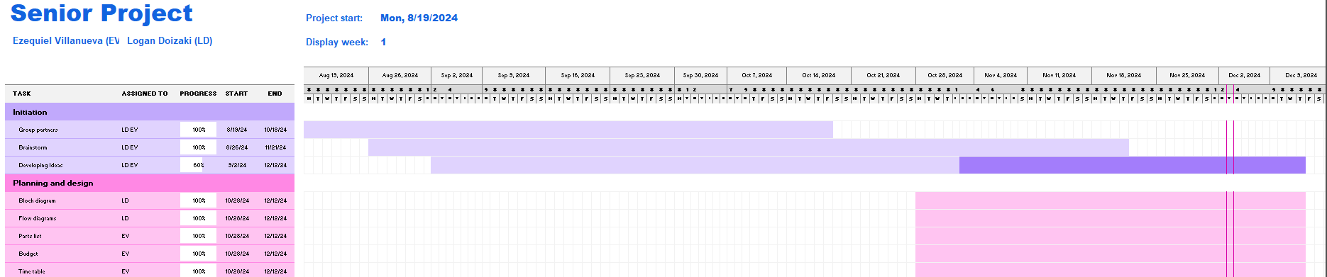

**Future Project Idea:**

Outlined below is a brief description of future add-ons.

**User Interface:**

After successfully implementing the button interface, more controllability over the RGB can be added by using knobs.

**LIVE FEED:**

The version being implemented is image processing. By being able to manipulate a single image, it should be achievable to translate the same process for a live feed since a video is just a series of images.

- These two block diagrams are two versions of implementing the live image processing device. The one on the left functions by doing RGB manipulation before being sent to the MCU. The MCU serves to only store and display the image.

- The second diagram shows the device being used as an attachment to the MCU. In this instance, the footage is first sent to the MCU. The device will then receive the image and process accordingly before sending the feed back to the device.